人工智能课程 作业5 提高版 6月15号11:59pm 提交， （2-3人一组）

本次作业请使用scikit-learn框架进行森林类别分类任务。scikit-learn是一种用于数据挖掘和数据分析的简单而独特的工具，现在我们将用它来对森林进行分类。在这个作业中，你要使用地图资料预测森林覆盖类型。数据来源于美国林务局资源信息系统数据，该数据给定了30×30米单元的实际森林覆盖类型。
研究区域包括位于科罗拉多州北部罗斯福国家森林的四个荒野地区。每个观测点都是30m x 30m的区域。要求预测森林覆盖的类型。这七种类型为：
1 - Spruce/Fir
2 - Lodgepole Pine
3 - Ponderosa Pine
4 - Cottonwood/Willow
5 - Aspen
6 - Douglas-fir
7 – Krummholz
训练集(15120个数据)包含地区特征和覆盖类型。测试集只包含地区特征。您必须预测测试集中每一行的覆盖类型(565892个数据)。
数据字段：
Elevation - Elevation in meters
Aspect - Aspect in degrees azimuth
Slope - Slope in degrees
Horizontal Distance To Hydrology - Horz Dist to nearest surface water features
Vertical Distance To Hydrology - Vert Dist to nearest surface water features
Horizontal Distance To Roadways - Horz Dist to nearest roadway
Hillshade 9am (0 to 255 index) - Hillshade index at 9am, summer solstice
Hillshade Noon (0 to 255 index) - Hillshade index at noon, summer solstice
Hillshade 3pm (0 to 255 index) - Hillshade index at 3pm, summer solstice
Horizontal Distance To Fire Points - Horz Dist to nearest wildfire ignition points
Wilderness Area (4 binary columns, 0 = absence or 1 = presence) - Wilderness area designation
Soil Type (40 binary columns, 0 = absence or 1 = presence) - Soil Type designation
Cover Type (7 types, integers 1 to 7) - Forest Cover Type designation
荒野地区包括：
1 - Rawah Wilderness Area
2 - Neota Wilderness Area
3 - Comanche Peak Wilderness Area
4 - Cache la Poudre Wilderness Area
土壤类型包括：
1 Cathedral family - Rock outcrop complex, extremely stony.
2 Vanet - Ratake families complex, very stony.
3 Haploborolis - Rock outcrop complex, rubbly.
4 Ratake family - Rock outcrop complex, rubbly.
5 Vanet family - Rock outcrop complex complex, rubbly.
6 Vanet - Wetmore families - Rock outcrop complex, stony.
7 Gothic family.
8 Supervisor - Limber families complex.
9 Troutville family, very stony.
10 Bullwark - Catamount families - Rock outcrop complex, rubbly.
11 Bullwark - Catamount families - Rock land complex, rubbly.
12 Legault family - Rock land complex, stony.
13 Catamount family - Rock land - Bullwark family complex, rubbly.
14 Pachic Argiborolis - Aquolis complex.
15 unspecied in the USFS Soil and ELU Survey.
16 Cryaquolis - Cryoborolis complex.
17 Gateview family - Cryaquolis complex.
18 Rogert family, very stony.
19 Typic Cryaquolis - Borohemists complex.
20 Typic Cryaquepts - Typic Cryaquolls complex.
21 Typic Cryaquolls - Leighcan family, till substratum complex.
22 Leighcan family, till substratum, extremely bouldery.
23 Leighcan family, till substratum - Typic Cryaquolls complex.
24 Leighcan family, extremely stony.
25 Leighcan family, warm, extremely stony.
26 Granile - Catamount families complex, very stony.
27 Leighcan family, warm - Rock outcrop complex, extremely stony.
28 Leighcan family - Rock outcrop complex, extremely stony.
29 Como - Legault families complex, extremely stony.
30 Como family - Rock land - Legault family complex, extremely stony.
31 Leighcan - Catamount families complex, extremely stony.
32 Catamount family - Rock outcrop - Leighcan family complex, extremely stony.
33 Leighcan - Catamount families - Rock outcrop complex, extremely stony.
34 Cryorthents - Rock land complex, extremely stony.
35 Cryumbrepts - Rock outcrop - Cryaquepts complex.
36 Bross family - Rock land - Cryumbrepts complex, extremely stony.
37 Rock outcrop - Cryumbrepts - Cryorthents complex, extremely stony.
38 Leighcan - Moran families - Cryaquolls complex, extremely stony.
39 Moran family - Cryorthents - Leighcan family complex, extremely stony.
40 Moran family - Cryorthents - Rock land complex, extremely stony.

请在下图中选择三到四种不同的算法来解决上述问题，并比较它们的优缺点。


要求：
1、在开始编写代码之前，请阅读示例文件LogisticRegression.py和scikit-learn帮助文件。
2、提交文件应该具有Id和预测的森林覆盖类型(包含1到7之间的整数)。请检查提供的提交示例文件sampleSubmission.csv。文件应该包含一个标题，格式如下:
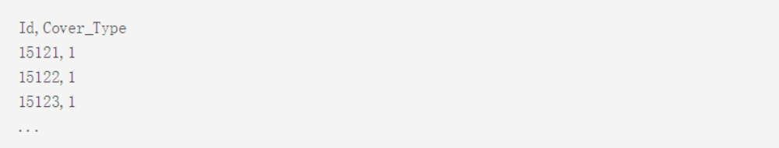
3、在编写程序中，我们强烈建议使用k-fold交叉验证。计算不同k下的均方误差。
4、您需要提交一个rar文件，包括所有的源代码和最佳预测结果csv文件。
5、请将提交的文件先提交于https://www.kaggle.com/c/forest-cover-type-prediction验证文件是否正确并计算准确率，基线程序准确率为70%，本次作业准确率高于70%以上的小组可以获得90分以上分数。

